**GCP Account Creation:**

(Note:Use visa or Master credit cards)

Following are the steps to create a free trial **GCP** account.

1. Go to the GCP website (https://cloud.google.com) and click the “Get started for free “ button.

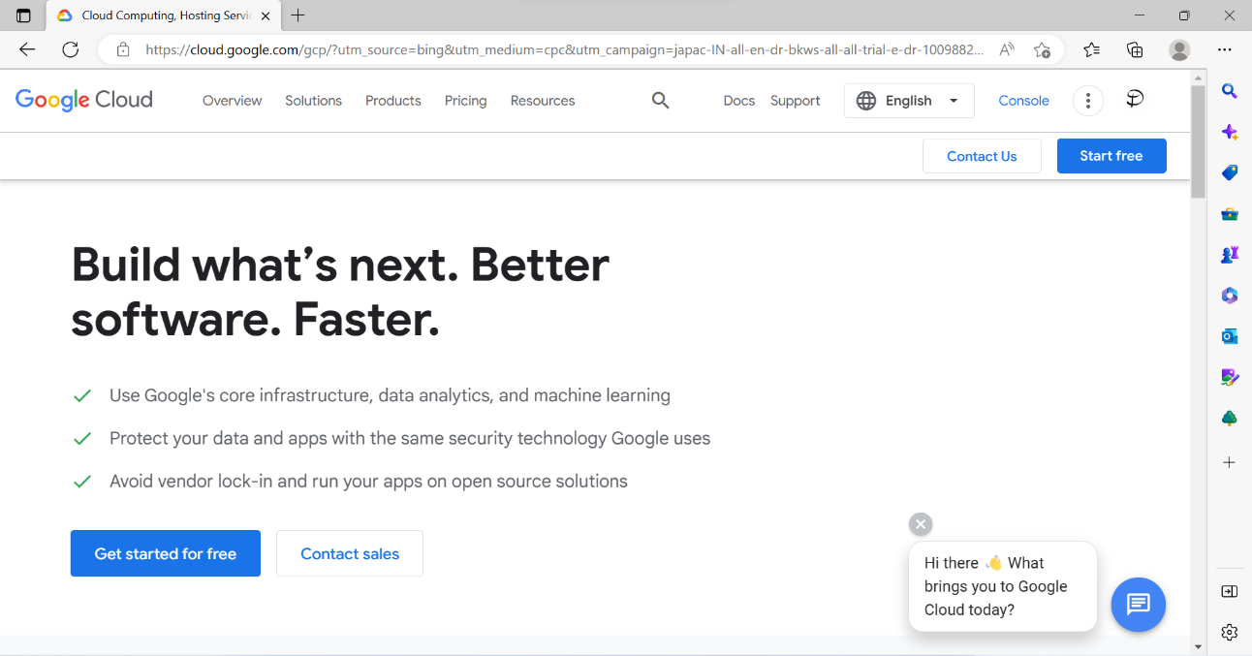



1. Create a new google account if you don’t have one or sign in with a google account.

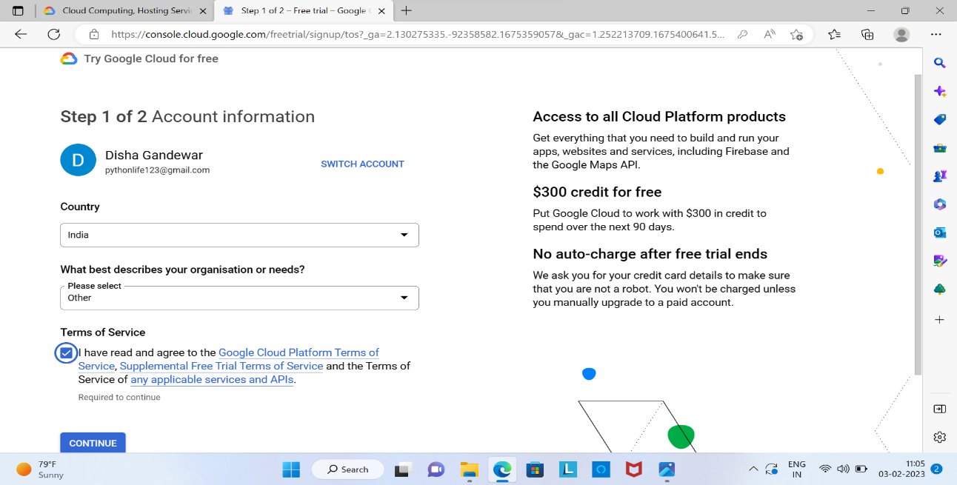



1. Fill out the required information,You will be prompted to enter credit or debit card,but you won’t be charged unless you upgrade to a paid account or use services outside the free tier.

* Select the Account type as **Individual**.
* Enter card details.

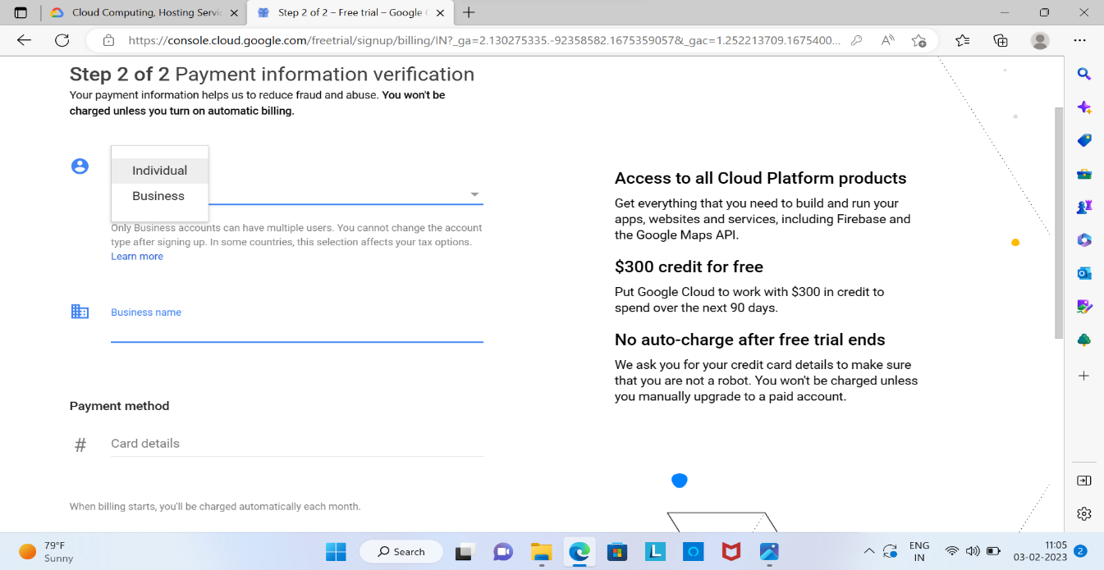

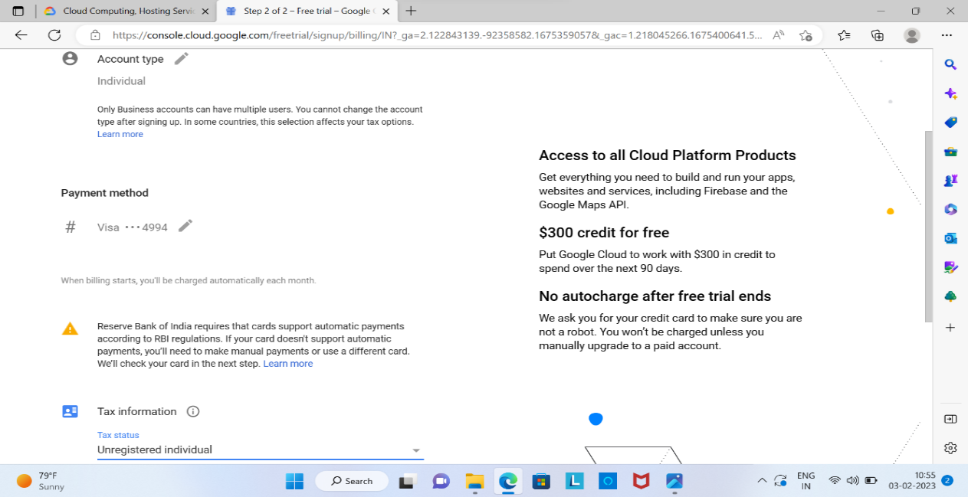

* Choose Tax status as **unregistered individual** option. Than click on **STRAT MY FREE TRIAL**.

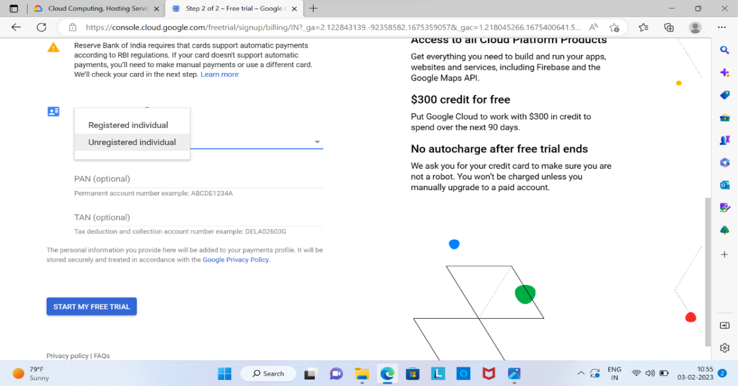

1. Enter 3-digit security code on your card, than click on **CONTINUE**.

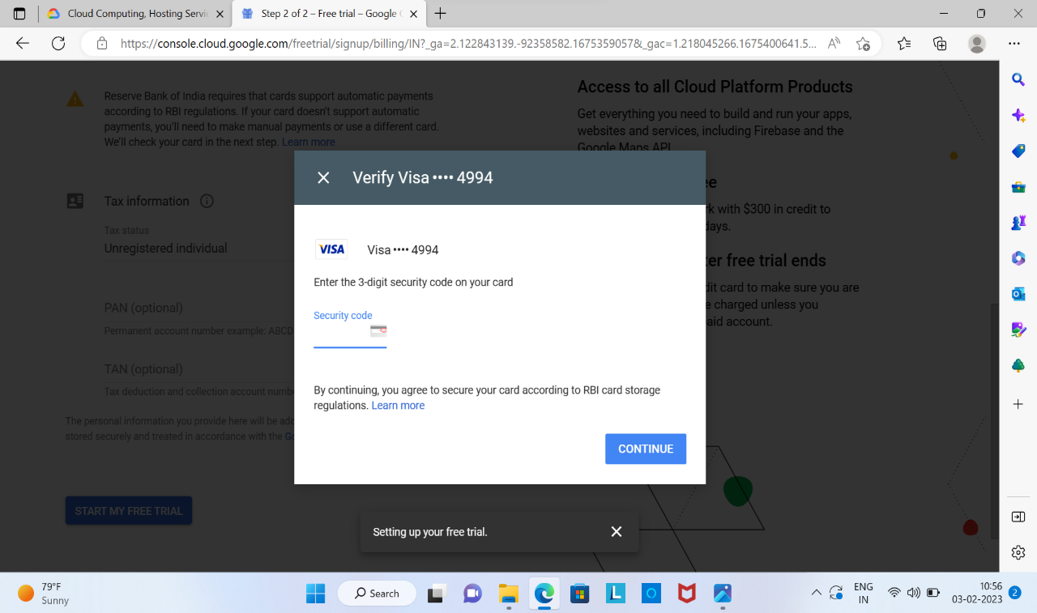



1. Verify your identity through a text message or phone call, After enter the **OTP** click on **CONFIRM**.
2. Now your GCP Free tier account is now created and you can start using it. You will get the dashboard as show below.

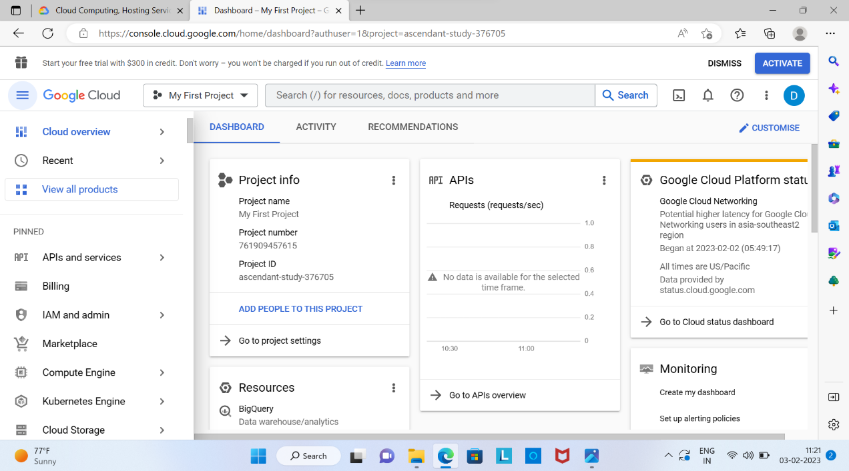



* Please note that free trial provides a limited amount of resources so be sure to monitor your usage to avoid any charges. Also, keep in mind that certain services may not be included in the free trial and may incur charges.